China support in Consumer Care Component

# 1. China specific solution for “Find Philips near you”

Google map based service location is not working in China. Whenever consumer care component detect the current user is China user (based on the country code from service discovery), China specific Baidu map service locator will be used:

The Baidu map based service locator is implemented by China IT team and hosted in a webpage. So the responsibility of CC component is just to load this webpage in case current user is China user. 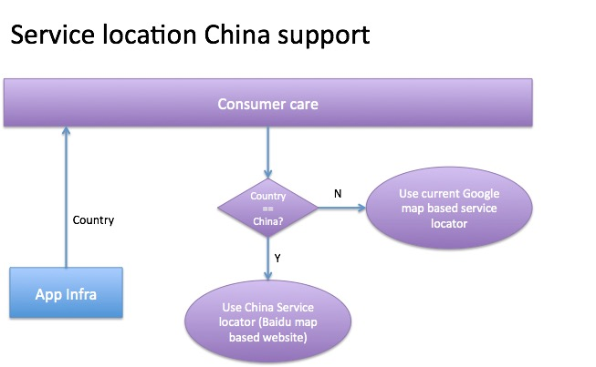

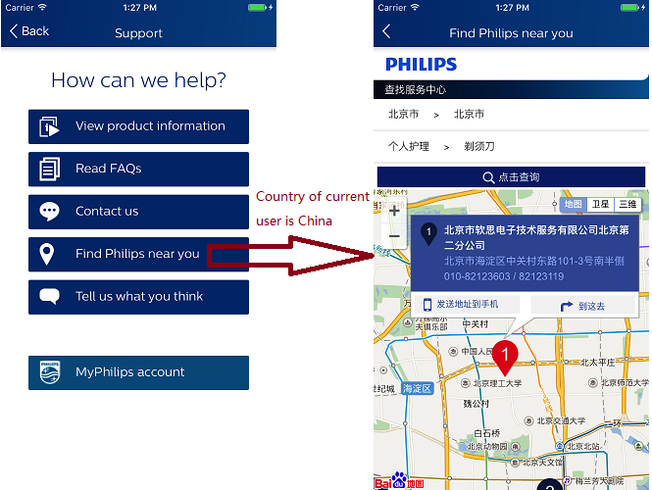

# 2. China specific live chat implementation

China have specific requirement for live chat:

1. In case user’s country is China, CC shall direct user to China specific LiveCom instance which is integrated with China consumer care system.
2. User’s phone number (from user registration component) shall be composed as part of LiveCom URL, as below: *http://test.livecom.cn/webapp/index.html?app_openid=philips&group_id=1&token={phoneNumber}*
3. User shall be able to upload picture in live chat screen (corresponding OS permission is required)

To enable this, we expose a API in CC to allow vertical app to provide customized live chat URL. In case this customized live chat URL is provided, we will use this URL when invoking live chat (instead of using the default chat URL in configuration file).

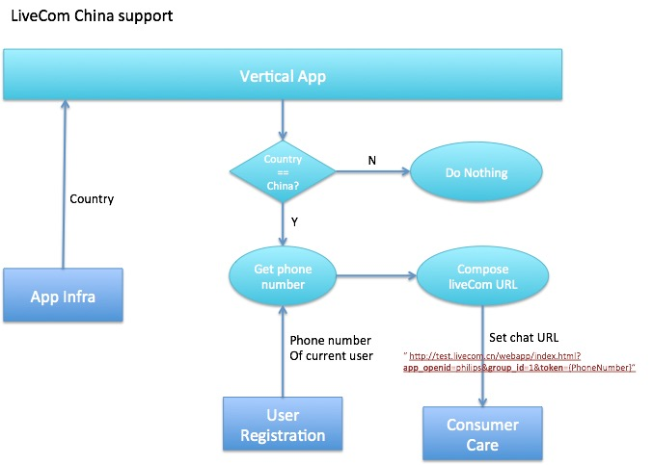

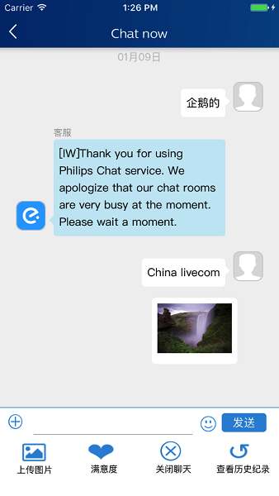

# 3. Disable social provider in “Contact us” screen

Current social provider “Facebook” and “Twitter” is not accessible in China. We need hide these entries for China user in “Contact us” screen.

CC will provide an API for configuration file path. In case of China user, vertical App can provide a China specific configuration file without social provider keys. And CC will hide social provider buttons on UI whenever no social provider keys are configured.

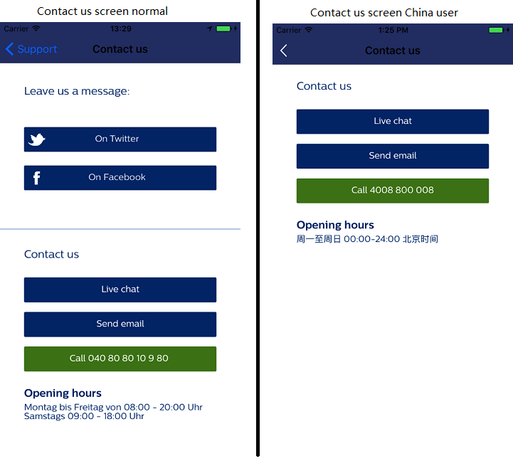

# 4. Disable “App rating” function in Android for China user

Google play store is not available in China. There are several Android stores in China where we will submit our Android mobile apps. We are not able to track in which store did the user download and install the app. And the rate functionality in China Android stores changes dynamically over time.

Based on these considerations, we disable the “Write an app-review” function for China user in Android. For iOS we keep the function as it is because the apple store in China got same functionality as other countries.